Technical Guide
Functional Block Diagrams
GPS And Server/Client Connection
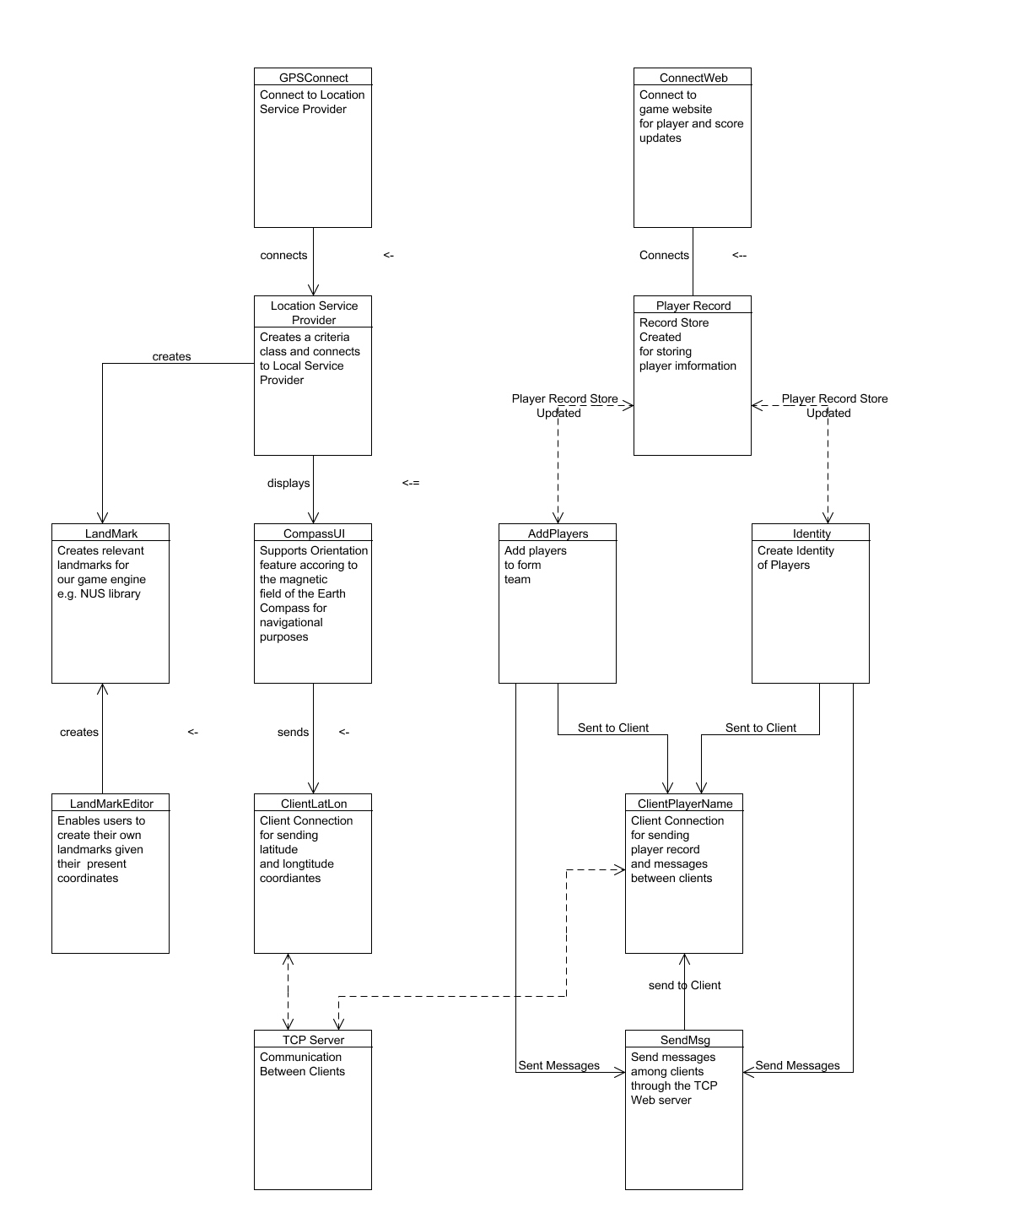

SVG Game Engine
MobileGameFramework
Main MIDlet for loading the map and the game.
SimpleEngine
Provides a simple interface for the game loop.
loads
MapEngine
Provides map/GPS functionality (see above)
extends
SVGEngine
Provides functionality for the game engine.
extends
Send: keystate
Send: elapsed time
Send: graphics context
Result: Update game
SimpleCanvas
Provides basic drawing functionality.

Send: Updated game
Result: Paints game
SpriteCache
Manages SVG façade for phones that can’t support direct hardware drawing of SVG graphics.
Request: Raster data for a SVG Sprite

Cache Loader
Stores/loads raster data in the phone’s memory, for phones that take a while to render via TinyLine.
Request: Store/load raster data.
Send: Raster data as a byte[]

Rasterizer
Uses TinyLine to pre-render all SVG graphics.
Send: The SVG file.
Result: A CachedSVG object with byte[]’s of raster data.

Map Editor
GUI for creating Java classes that correspond to maps. Can also (somewhat) create SVG Sprites.
Generates CachedSVG sub-classes for use by the SpriteCache

Bluetooth Façade
Passively scans for other players; allows connections, sends updates if connected.
Send: velocity updates for Player1.
Receive: velocity updates for Player2

Specifications
Target Client Device Specification
- Motorola V3i
Minimum Specification: 6Mb available memory, Java MIDP 2.0 Compliant, Bluetooth, GPRS connectivity.
- Dopod 577W
Minimum Specification: 6Mb available memory, Java MIDP 2.0 Compliant, Bluetooth, GPRS connectivity.

Target Server Specification
- TCP Game Server
Minimum Specification: J2ME MIDP 2.0
Self Implemented Multithreaded TCP Server architecture provides data transfer among multiple clients.
- Apache Tomcat server for serving JSP pages.

Server Installation
- Run Server program on local web server
- Server program connects to port 8000 and listens to client connections at port 8000

Client Installation
- Install Netbeans 5.0, inclusive of Mobility Pack and jdk 1.5
- Install Nokia Prototype SDK 4.0 in order to run GPS satellite functionality
- Download SVG TinyLine and include Tinyline libraries in program
- Make sure the resource folder is included
  - Click on Project
  - Under Properties -> Click on Libraries and Resources
  - Include TinyLine library and resource folder

- Deploy program in Netbeans
- Download jar/jad files into mobile device equipped with GPS receiver and must be SVG compatible

Programming Hardware Requirements
- TCP Web Server
- Unix Server (Subversion) for development
- Possible JSP-powered server (likely Unix) for accumulating user’s statistics
- Dopod 577W Smartphone, for deployment testing

Programming Software Requirements

- Nokia Prototype SDK 4.0 for Location API supported emulators
- J2ME Wireless Toolkit 2.5
- NetBeans IDE
- NetBeans Mobility Pack
- Compliance to the MIDP 2.0 strategy
- SVG Tiny 1.2
- TinyLine SVG rendering engine, for phones w/o SVG support.
- “Mobile Designer”, “GLIPS Graffitti”, or some other SVG authoring tool.
- TortoiseSVN (Subversion)
Features

GPSLocation
The game uses Location API to obtain information about the location of a mobile device in terms of its latitude and longitude positioning. Because it was impractical for us to test the system in a real device, we created a simulated environment using the Route tool provided by Nokia Prototype SDK 3.0 (available through the Tools/Utilities menu). In the Route tool, we painted our route and saved it on NMEA 0183 format for our game’s usage. Since J2ME did not support parsing of Strings, we created our own parser for interpreting the NMEA format and extracted coordinates in real time.

We used the following criteria parameters to connect to an “imaginary” location provider. In practice, we need to define the exact criteria that best matches the location provider within the country or region.
Criteria crit = new Criteria();
crit.setHorizontalAccuracy(25); // 25m
crit.setVerticalAccuracy(25); // 25m crit.setPreferredResponseTime(Criteria.NO_REQUIREMENT); crit.setPreferredPowerConsumption(Criteria.NO_REQUIREMENT); crit.setCostAllowed(false); crit1.setSpeedAndCourseRequired(true); crit.setAltitudeRequired(false);
crit.setAddressInfoRequired(false);

Landmark Store
We stored the landmarks required for our game in a landmark store. Categories can be added to group the landmarks, making it easier to find landmarks from the store. The Location API enables our game to add new categories, remove existing ones, and basically manage the landmarks, easing our implementation efforts.

Orientation
Our game supports orientation of the device. This means that if the device contains a hardware magnetic sensor, the orientation is given as magnetic angles to our game application.

Server Implementation
Basically, our server can handle multiple TCP/IP connections and support the entire communication protocol between clients. Clients can send messages to one another cost-free through our servers, instead of using conventional SMS or phone calling. All game information and coordinates are sent through the servers to ensure consistency in game states. The server also connects to our game website detailing the team information and scores. For simplicity, we created a jsp web page to extract game information from our program.
The layout of the server is:
- Create an Accept thread to accept connections on port 8000
- Get a connection, create a new accept thread to be able to handle more connections.
- Log this person in, getting user name.
- Create a lobby of sorts where you can do simple chat, create a new game, or join a game,
- This lobby reads a line of input from the socket, and then checks what the command the user typed was
- When the person creates a game, we add the game object to a pending list, and wait for someone to join the game.
- When a person joins a game, we check for the game name on the pending list, and assign that person as the second player on that game object.
Player Record Store
We created a Record Store for persistent storage of players information, that is to save important information before execution of the program stops, such as scores in the game, player details etc. We created methods for adding, updating, deleting and retrieving player records from the record store, formulating a convenient and easy-to-use infrastructure for data management.

Resizeability
The game uses cached SVG graphics, which can be resized to arbitrary proportions using the “Zoom” MIDlet. Compare the following screenshots, one at 1.25x resolution, the other at 3x resolution, and note no anti-aliasing defects:

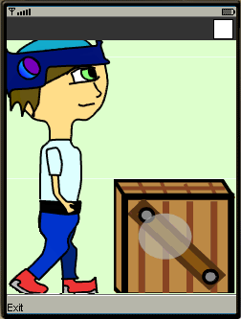
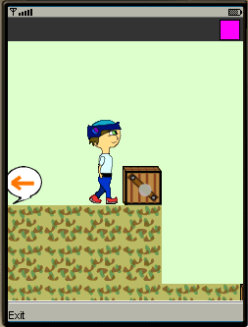

Efficiency

Initial Efficiency Concerns
Initially, the game ran prohibitively slow. This was determined to be because of the TinyLine drawing routines, which simply didn’t perform well enough for usage in a game. Hence, the game engine’s use of SVG was restricted to graphics alone (i.e., not animations), and animation was mimicked through use of frames of SVG images, which could then easily be cached in the phone’s memory. This improved performance drastically, and was the only speed fix we needed to implement.

Outstanding Efficiency Concerns
Currently, the game engine runs fine on the tested device (Dopod 577W). However, this is probably not a good estimate of performance. For instance, the Dopod’s available memory is above that which the default emulator is willing to simulate. Moreover, the game occasionally “forgets” about objects, and zooming in causes the game to slow down notably. The following tables summarize some solutions that developers with access to the source might wish to consider. Those in the same-lettered category conflict with each other (so, it would be prudent to complete only the tasks in either A-1, A-2, A-3, or A-4, but not all four.) Also, some options such as resizing on the server, are not necessarily ideal.

 | Table 1: Out-Of-Memory Solutions
 | Idea | Est. % Saved | Saved For… | Time to Implement
Category A-1 | Zip SVG files | 10% | SVG Size | 1 h
 | Don't format for readability | 5% | SVG Size | 0.5 h
Category A-2 | Custom binary storage format | 50% | SVG Size | 4 h
 | TinyLine ONLY; use code files w/ TL primitive drawing instructions | 20% | SVG Size | 3 h
Category A-3 | Custom drawing format & processor; no TinyLine | 80% | SVG Size | 10 h
Category A-4 | Re-size on server only | 99% | SVG Size | 0.5 h
Category B | Better re-usability w/in code (i.e., boulders can just be rotated) | 10% | SVG Size | 2 h
 | Better storage (i.e., don't cache players' left/right anims; re-compute on load each time. Don't save rotates either) | 15% | Bytes Cached | 2 h
 | Better compression (e.g., half-width colors) | 8% | Bytes Cached | 2 h
 | Delete un-necessary resources saved in the folder | N/A | JAR Size | 0.5 h

 | Table 2: Out-Of-Processing-Power Solutions
 | Idea |  |  | Time to Implement
Category A | As tiles are drawn, set flags for objects not in view; don't paint them. |  |  | 3 h
 | Set some objects as "live" if their velocity is not 0. When they interact with other objects, these objects and the ones adjacent to them become "live" for a set time. Kind of an over-simplification of Newton's laws, since tiles never change. ("A box on the ground won't move.") |  |  | 5. h
 | Improve on the above; figure out rules such that objects are only live when it is sensible for them to be so. |  |  | 4 h
 | Debug: show an item's activeness (red, semi-transparent overlay) |  |  | 1 h

Errors

Target Device Concerns
The Dopod proved to be slightly uncooperative. For one thing, it lacked certain conspicuous libraries which caused runtime Errors which were often hard to pin down. One of these errors involved a class which reads file sizes. Another, unfortunately, crashed when linking to the Bluetooth libraries. In the end, the game simply doesn’t work on the Dopod. This might be easily fixed, but more pressing concerns demanded that development continue on the emulator alone.

Hit Detection Errors
The game engine runs very smoothly; however, there are a few glaring errors with hit detection. For one thing, hits sometimes just don’t happen. They also slow down execution of the program, so if a box were to fall through a gem (when they collide, nothing happens) the box will slow down. The first problem is a simple debugging matter. The second one could easily be solved by having a “no hit” table which lists which objects have no effect on each other. In fact, the entire “collision” idea could be abstracted, and Interfaces with the collide() functions themselves could be stored in this table. This is, I believe, much more succinct, but again, more pressing issue remained.

Bluetooth Timing Errors
The way that data is sent via Bluetooth is currently slightly improper, such that inconsistencies in the game state often come about. This can result in victory occuring improperly, or in heroes bumping into things that don’t exist.

